Answer of Question 1 to Question 3 Final examination CSC435 2017 Mac

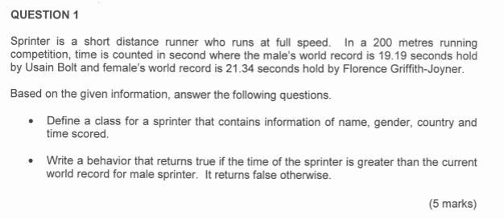

Public class Sprinter

Private String name;

Private char gender;

Private String country;

Private double time;

Public Boolean fasterMale()

{

If( (gender == ‘M’) && (time>curMale))

return true

Else

return false

}

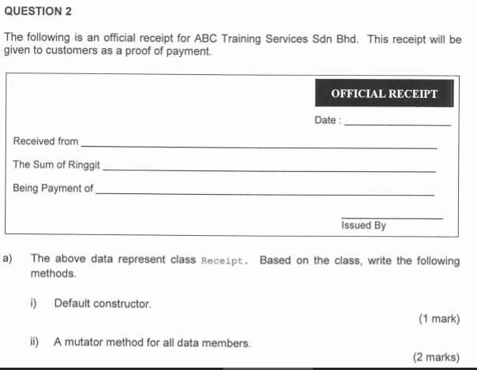

i)public Receipt()

{

DateReceipt = “”;

NameReceipt = “”;

SumReceipt=0.0;

ii) Public void setData(int d, String nR, double S, String Ap, String assBy)

{

date = d;

nameReceived = nR;

sum = S;

Aimpayment = Ap;

assignedBy = assBy;

}

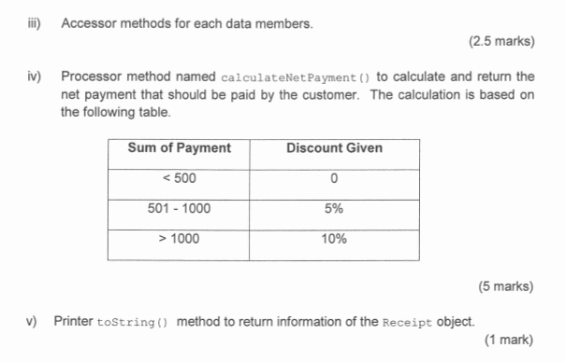

iii) public int getDate()

{ return Date; }

public String getNameReceived()

{ return nameReceived;}

Public double getSum()

{return sum;}

-aimpayment

-assignedby

iv) //processor

Public double calculateNetPayment()

{

Double Payment;

If(sum< = 500)

{

Payment = sum;

}

Else if (sum<=1000)

{

Payment = sum\*0.95;

}

Else

{

Payment = sum\*0.90;

}

Return Payment;

}

v) public String toString()

{

return “\nDate:”+date+

“\nReceivedfrom:”+nameReceived+

“\nSum:”+sum+

“\nBeingPaymentof;”+Aimpayment+

“\nIssuedby:”+assignedBy;

}

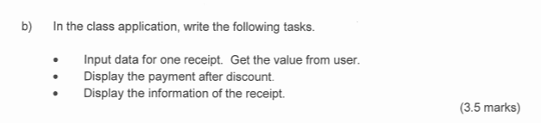

Public static void main(String [] args)

{

Receipt rcp = new Receipt ();

Scanner s = new Scanner (System.in);

String dt, by, forP sm;

Double pr;

System.out.println(“Enter date receipt: ”);

Dt = s.nextLine();

System.out.println(“Enter name : ”);

by= s.nextLine();

System.out.println(“Enter sum receipt: ”);

pr= s.nextDouble();

System.out.println(“Enter aim payment receipt: ”);

forP= s.nextLine();

System.out.println(“Enter the person assigned receipt: ”);

sm= s.nextLine();

rcp. setData(dt, by , pr, forP, sm);

//display

System.out.println(“The payment after discount : ” + rcp.calculateNetPayment);

//display

System.out.println(“The info : ” + rcp.toString());

}

